**Esenin, Sergei** (also **Yesenin**; Есе́нин Серге́й) (1895 – 1925)

Sergei Alexandrovich Esenin was one of Russia's major lyrical poets. He described himself as ‘the last poet of the village.’ Raised in a peasant family, Esenin drew inspiration for his poetry from Russian folklore, Orthodox faith, and traditional pagan beliefs that were wide-spread among peasants. Esenin’s early contemplative lyrical verse (1914-1916) idealized Russian nature and the village. The poet originally supported the October Revolution but was later disillusioned by the Bolshevik regime. In his poetry, he lamented the destruction of the traditional peasant way of life. Esenin was a founding member of the Imaginist group (1919-1924), which insisted on the primary role of the image in literature. Esenin’s poetry of the 1920s is markedly pessimistic. Following the poet’s suicide in December 1925, Esenin’s poems that expressed decadent attitudes toward life and his sensational self-destructive behavior were criticized by Bolshevik leaders and critics as ‘*eseninshchina*’ (Eseninism). Esenin’s works were not republished in the Soviet Union until the 1960s. However, despite this unofficial ban, his poetry was always popular and often circulated in handwritten copies.

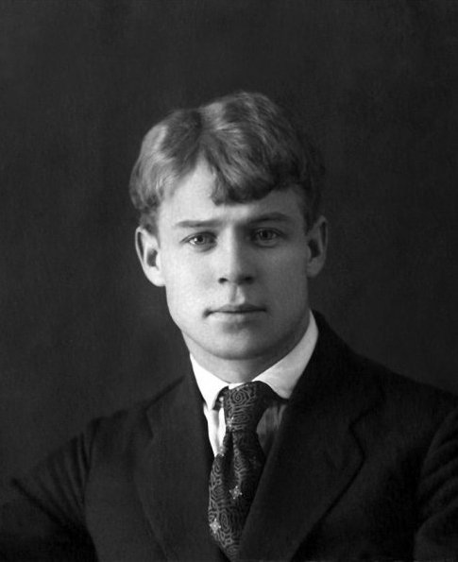

Sergei Alexandrovich Esenin was born to a peasant family on 3 October 1895 (21 September 1895 Old Style) in the village of Konstantinovo (now Esenino), Ryazan Province. Esenin was mostly raised by his maternal grandparents, wealthy peasants who were members of the Old Believers. Esenin attended a village school from 1904 to 1909 and then continued his education in the church boarding school for prospective teachers.

In 1912, at his father’s request, Esenin moved to Moscow. From March 1913 he worked as a proofreader’s aid in a printing company while continuing to write poetry that was inspired by religious spirituality and folklore. Esenin's first publication was the famous landscape poem ‘The Birch Tree,’ which appeared in January 1914 in the children's magazine *Mirok*. In hopes of establishing himself as a poet, in early spring of 1915 Esenin moved to Petrograd (now St. Petersburg), which was then the center of Russian literary life. Recognizing Esenin’s unique talent, Alexander Blok introduced him to prominent literati. Esenin’s poetry of the period was influenced by Blok, Andrei Bely, and Nikolai Kliuev. Fame came to Esenin after his first collection of poetry, *Radunitsa* [*Mourning for the Dead*] was published in 1916. Esenin’s early contemplative lyrical verse idealized Russian nature and was a celebration of life in the village.

During World War I, from 1916 to 1917, Esenin was drafted into military duty. During this period, he had an opportunity to recite his poems to Tsarina Alexandra and other members of the tsarist family. In the summer 1917, Esenin deserted. Having first embraced the October Revolution, Esenin was gradually disillusioned by the Bolshevik regime and, in particular, lamented in his poetry the destruction of the Russian village. He described himself as “the last poet of the village.”

In 1919, together with Anatoly Marienhof, Esenin founded the Russian literary movement Imaginism. The group, active until 1924, emphasized the role of the image in literature, claiming that a poem’s content was less important that the binding structural significance of the poem’s images. Sophisticated and elegant in form, Esenin’s poetry of the 1920s is markedly pessimistic. His collection of poems *Moskva kabatskaia* [*Moscow of the Taverns*] is known as the quintessential expression of decadent attitudes. Esenin’s creative legacy of the 1920s also includes poems inspired by his extensive travels to Central Asia and the Caucasus. The collection of poems *Persidskie motivy* [*Persian Motifs*] contains some of the best examples of Esenin’s love poetry.

At the age of 30, while suffering from acute depression, Esenin committed suicide by hanging. He was found dead on 28 December 1925 in his room in the Hotel Angleterre in Leningrad (now St. Petersburg). The day before, he gave his friend, Wolf Ehrlich, his last poem ‘Goodbye My Friend, Goodbye’ [‘Do svidaniia, drug moi, do svidaniia’]. It was written with Esenin’s blood because there was apparently no ink in the room. Esenin was buried in Moscow's Vagankovskoye Cemetery. Esenin’s decadent poems of 1924-1925, his alcoholism, and his dissolute self-destructive behavior were criticized by Bolshevik literary critics. Esenin’s works were not republished in the Soviet Union until the 1960s, while expressions of decadence in art and in everyday life were branded as “eseninshchina” (Eseninism).

Esenin’s personal life was complicated. His common-law marriage to Anna Izriadnova lasted from the winter of 1913 until early spring of 1915. In this marriage Esenin’s son Yuri was born. In the summer of 1917, Esenin married Zinaida Raikh, who later became an actress and the wife of Vsevolod Meyerhold. With Raikh he had a daughter, Tatyana, and a son, Konstantin. Esenin left the family in 1921. In May 1922, he married the famous American dancer Isadora Duncan and shortly afterwards went with her on a tour of Europe and the United States. The poet detested the West’s philistinism and greed. Upon his return to Russia in 1923, he separated from Duncan. Following a number of romantic relationships between 1923 and 1925 (in 1923 Esenin had a son with the poet Nadezhda Volpin), in the spring of 1925 Esenin married Sophia Andreyevna Tolstaya, a granddaughter of Leo Tolstoy.

# **Major Works:**

“The Birch Tree” (1913)

“Autumn” (1914)

*Radunitsa* (*Mourning for the Dead*) (1916)

“I Left the Native Home” (1918)

“Hooligan's Confession” (1920)

“I am the Last Poet of the Village” (1920)

“I Don't Pity, Don't Call, Don't Cry” (1921)

*Pugachev* (1921)

“A Letter to Mother” (1924)

*Moskva kabatskaia* (*Moscow of the Taverns*) (1924)

*Ispoved’ khuligana* (*Confessions of a Hooligan*) (1924)

“A Letter to a Woman” (1924)

*Rus’ sovetskaia* (*Soviet Rus’*) (1925)

*Persidskie motivy* (*Persian Motifs*) (1925)

*Chernyi chelovek* (*The Black Man*) (1925)

“To Kachalov’s Dog” (1925)

“Goodbye, My Friend, Goodbye” (1925)

# **Further Reading:**

Esenin, Sergei. *Selected Poetry*. Transl. Peter Tempest. Moscow: Progress Publishers, 1982.

Yesenin, Sergei Aleksandrovich. *The Collected Poems of Yesenin in English Textbook Binding*. Translated by Gregory Brengauz. Tallahassee, Fla.: Floridian Publisher, 2000.

Ponomareff, Constantin V. *Sergey Esenin*. Boston: Twayne Publishers, 1978.

McVay, Gordon. *Isadora & Esenin*. Ann Arbor, Mich.: Ardis, 1980.

McVay, Gordon. *Esenin: A Life*. Ann Arbor, Mich.: Ardis, 1976.

**Elena V. Baraban, University of Manitoba**

Source url for image: http://en.wikipedia.org/wiki/File:Esenin_Moscow_1922.jpg